Telemedicine Trial System for Personalized Follow-up Support of Patients with Chronic Obstructive Pulmonary Disease (COPD)
  - Results and experiences from automatic health status assessment and risk estimation algorithms

Internal report of the Center for eHealth and Healthcare Technologies at the University of Agder, Grimstad

Author names and affiliations:
Martin Gerdesª, Frode Gallefoss^{b}, Rune Werner Fensliª
ª Center for e-Health and Healthcare Technologies, Department of Information and Communication Technology, Faculty of Engineering and Science, University of Agder, Postboks 422, 4604 Kristiansand, Norway, {martin.gerdes, rune.fensli}@uia.no
^{b} Head of Clinical Research, Sørlandet Hospital, Postbox 416, 4604 Kristiansand, Norway, frode.gallefoss@sshf.no

Keywords
COPD; Decision Support Techniques; Telehealth; Remote Monitoring; Personalized Health Status Assessment Algorithms; Triage

Highlights
- Monitoring of 94 COPD patients, 70 days (average), 75% daily reporting completeness
- Evaluation of automatic health assessment of multiple patient-reported modalities
- 10% of calculated health status scores overwritten manually, mainly as false-high
- Static rules and cut-off values not sufficient for reliable and efficient follow

Structured abstract
Objective
The use of telemedicine systems by patients reporting vital signs measurements and other health-related data from their home is evolving and has been studied and published by many research projects. In such a scenario, the reported data are received at a telemedical centre, where trained nurses follow up on the actual patient’s condition and initiate necessary interventions. In some systems a color-coded assessment algorithm (called triage in medical vocabulary) is implemented in order to determine fluctuations and exacerbations of patients’ conditions and to provide the healthcare staff with necessary alerts and information to support the prioritization of individually adapted support actions or interventions.
Based on data reported by COPD patients with a pilot system developed for the EU-funded research project United4Health in South-Norway [1], we analyze on the one hand the reporting behaviour of the patients and their health status development during the trial participation, and on the other hand how the nurses at the telemedical centre utilized and adjusted the automatic health status assessment of those data. The evaluation of different assessment algorithms is expected to allow recommendations for future methods, together with improved cut-off values for warnings and alarms when actions are needed.
Methods
Patients were recruited to use a telemedicine monitoring solution for a defined period of 30 days after discharge from hospital treatment for acute exacerbations. For the first two weeks, they were instructed to report daily measurements of pulse and transdermal peripheral capillary oxygen saturation (SpO₂), in addition to a symptom specific questionnaire. Based on reported data, the telemedicine system determined a color-coded health status level for each reporting patient for that day. The calculation algorithms used defined cut-off values, as absolute generic as well as individual personalized values. Nurses at the telemedical centre, responsible for the patient monitoring, got instantly an overview of all monitored patients, sequenced with red alerts for the most critical patients. In individual cases they could manually overwrite the assessment level, assigning a different colour code according to the patient’s condition observed through a video or telephony consultation.
Results
The evaluation of 4970 datasets from 94 tele-monitoring patient interventions provided insights in the long-term reporting behaviour: during the mean trial participation duration of 70 days, the average daily reporting completeness was around 75%-80%, while only around 25% of the patients reported every day during the first week and less than 10% during the whole first 30 days. The automatic health status assessment, done by the combinatorial fusion and evaluation of the reported pulse-oximetry values and subjective answers to a symptom specific questionnaire, showed stable conditions during about 50% of the whole monitoring period, about 30% notable conditions, but also 20% of alerts of critical conditions. The analysis of the manual adjustments of the automatic health status assessment by the telehealth nurses revealed the frequency of about 10% and also reasons for the adjustments. Alternative assessment algorithms were compared in retrospective calculations.
Conclusion
The evaluation and comparison of different health status assessment algorithms to be used for the real-time calculation of color-coded health status assessments levels for the decision support of telehealth nurses allows recommendations for alternative assessment algorithms and for procedures for the determination of cut-off values. It also revealed that the sensitivity and specificity of such algorithms should be challenged in future studies.

Introduction

Aim of the Study
Remote home monitoring of patients with chronic diseases has been a topic of many research projects [2-7], where the main goals were to help patients in daily life situations, to increase their individual perception of security even under worsened medical conditions, to reduce home visits by doctors or nurses, and to avoid unnecessary hospital admissions and readmissions. For the EU-funded project United4Health [1], a solution was developed that utilized video communication technology to support patients at home with medical advice from a trained nurse at a centralized telemedical centre in order to take necessary actions like changes in inhalation therapy or start of antibiotic treatment. The actual interventions to be proposed by the nurse depended on the medical condition of the patient, as assessed by the data reported by the patient. These data included measurements of the transdermal, peripheral capillary oxygen saturation of the blood (SpO₂), the heart rate, and information about the patient’s subjectively observed symptoms, as gathered through a daily questionnaire. The reported data from the patient were instantly evaluated automatically by a health status assessment algorithm, creating a colour code that provided the nurse with a quick overview of the actual patient condition. On daily basis the patient’s reported condition would be followed by a video consultation.
The analysis of long time-series of vital signs data from patients at home over periods of weeks or months is both a new opportunity as well as a new challenge for healthcare services, and differs from traditional monitoring procedures in a hospital ward or under emergency conditions. While typically triage (also called “trauma triage”, “emergency triage” or “emergency department (ED) triage”, [8] [9]) is defined as “the process of classifying patients according to injury severity and determining the priority for further treatment”, the long-term follow-up of patients with chronic diseases has to adapt the treatment and medication to the long-term development and short-term changes of the condition of the individual patient and the corresponding needs for support and intervention. In order to avoid confusion between the objectives of clinical “ED triage” and of the long-term monitoring and decision support for treatment and follow-up prioritization of home-based patients, the terms “health status level assessment” and “health status score calculation”, respectively, will be used in this study.
The main objective of the EU-funded United4Health project was to gain insights in challenges and obstacles when deploying new telehealth solutions at broad scale in a sustainable way, and how those services can be adopted to existing routines and health care procedures. An important aspect of the routine procedures was the self-reporting of the actual condition and the use of the provided telemedical equipment by the patients. The South-Norway Site of the United4Health project has developed a solution for remote home monitoring of home-based COPD patients, where the patients used a tablet PC device and a pulse-oximeter for their measurements and daily self-reporting to a database securely stored within the Norwegian National Health Network. To this the doctors at the hospital (COPD Specialist Services), the inter-organizational telehealth centre operated by the municipality health care services (secondary health care level) and the local doctors (General Practitioners, GPs) had access. The solution is further described in this paper.
Difficulties arise in the determination of actual algorithms for automatic health status score calculations, and in the definition of cut-off values for the different reported modalities in order to trigger the correct colour-coded alarm-level for such remote home monitoring situations. For the trial system a dedicated assessment algorithm was defined by the consortium in the clinical protocol, utilizing the combinatorial fusion of multiple modalities. Based on experiences from 94 patients included in the clinical trials, the trained nurses at the telemedical centre in many cases had to manually override the automatically calculated health status colour code. In order to investigate the reasons for those manual overrides, we have investigated nearly 5000 datasets, with the aim of defining recommendations for improved algorithms for automatic calculations of a health status score. Such improvements will be of importance for routinely use of self-management and telehealth solutions for patients with COPD (and also other chronical diseases), and are relevant also in decision support systems that give telemedicine nurses a more reliable tool helping them in giving the patients correct medical advises.
In our study, we explain and retrospectively evaluate algorithms for the automatic calculation of an individual COPD health status score applicable for self-reported multi-modal patient health-status data. The first algorithm is implemented according to a defined clinical protocol where cut-off values are defined according to best clinical practice. The obtained accuracy of this and two additionally proposed alternative algorithms is evaluated retrospectively with data from the clinical trial by comparing the calculated health status levels with the manual override actions made by the nurses. The number of patients included in this sub-group study (33) and the length of the considered monitoring period (first 30 days) is comparable to the studies of Velardo [5] and Segrelles-Calvo [7] (see more details in scientific background below). In addition to common clinical practice, we introduce a “yellow” health status level in our clinical trial protocol as an early warning indicator of a “notable” health condition, and evaluate the impact on the monitoring routines.
The results of this study should help to answer the following research questions:
- Do the data collection, transmission, and evaluation algorithms of the analysed telemonitoring service provide decision support information for the monitoring health and care professionals in a manner as they need it to provide reliable and efficient health and care follow-up for the remotely monitored COPD patients, according to their individually reported multimodal conditions and the corresponding support needed?
- Do the implemented health assessment algorithms provide the required adaptation of health status levels and corresponding alerts for treatment and follow-up needs to the individual medical condition of each patient?
- Are the used cut-off values for the determination of the actual health status level of each patient along the different reported modalities appropriate for the decision support and prioritization of follow-up actions? What recommendations can be given for improved cut-off values and algorithms, or for procedures to define or calculate appropriate values?

Scientific Background
Chronic Obtrusive Pulmonary Disease (COPD) encounters for reoccurring emergency admissions, and is projected by the World Health Organization (WHO) to become one of the four leading causes of death worldwide by 2030 [10]. Telehealth solutions are expected to help patients with chronic conditions in their daily life, to manage a worsened condition without the need of emergency hospital care. Results from the “Whole System Demonstrator” (see [2]) showed that telehealth follow-up of patients with chronic conditions resulted in lower mortality and lower emergency admission rates, compared to a control group in a clustered randomized control study. Odeh et al. investigated a Telemedicine Service for patients with COPD and heart failure [3], which was provided for 36 months to 48 patients, and led to the clinical outcome of reduced acute and emergency visits including reduced hospital admissions due to all causes by 13%. It is anticipated that patients’ daily self-reported symptoms correlate with patient deterioration [11]. However, patients with chronic diseases can also experience difficulties in using mobile technologies for self-management due to cognitive impairments [12], and careful attention should be paid to the design of such solutions. Liliholt et al. followed the TeleCare North trial in Denmark [13], and found that technical skills and health literacy are no prerequisite for the patients to use the Telekit system for reporting their vital signs measurements.
New eHealth and mobile health (mHealth) telemedicine solutions have evolved over the past years, and according to Hofstede et al. [14] patients have general knowledge of such solutions, but no clear understanding of their advantages. However, almost half of the 400 patients in their telephone survey considered the possibility of taking more responsibility for their own care and self-management. When involving patients in a user-centred design, telehealth solutions for patients with COPD at home can be developed with focus on user-friendly functionalities and interfaces [15]. Nevertheless, Liu et al. have found conflicting evidence in their systematic review [16] that home health monitoring technologies can be of help addressing the patients’ condition of COPD, but as telemonitoring interventions are relatively new, the results might have been influenced by usability problems.
In the UK, 12 telehealth systems were analysed for their use of information exchange between patients and health care professionals [17]. Data analysis methods with predefined algorithms to be configured by the health professionals were implemented in 11 of the systems. In four of the investigated systems, a colour-coded format was used to indicate the severity of the patients’ status and the priority of support and follow-up; at the same time occasionally false positive and false negative alerts were encountered. An Internet-linked tablet PC for self-reporting of daily symptoms and pulse-oximetry measurements has been studied by Farmer et al. [4]. Their so-called “EDGE platform” gave the clinicians timely and immediately available information without overwhelming flow of data, although no immediate alerts were implemented - the response from the clinician was based on 4-day intervals. The EDGE-platform used a 95th centile as alert threshold for heart rate and oxygen saturation measured with a pulse oximeter and calculated from an initial 6-week period, allowing their web-based system to give valuable tailored alerts for the additional period.
Triage as a method for assessing the severity of injuries was originally developed by Champion et al. for emergency medical care [18]. They described a Triage Index to be used for the determination of injury severity in order to prioritize the acute assessment with available therapeutic resources. Shelton evaluated the use of a 5-level Emergency Severity Index [19] to easier and faster determine the needed care in emergency departments, and the use of triage methods for defining the patients’ actual condition has been expanded also for the utilization in telehealth solutions.
Manually entered threshold values for certain measured life signs can be used for generating alerts or calculating a triage colour-code indicating the patient’s actual condition. Such threshold values can be given as general recommended fixed limits, or can be manually adjusted to the individual patient needs based on clinical evaluation. In a COPD pilot monitoring study, Velardo et al. [5] analysed retrospectively an electronic diary questionnaire of 18 patients over a period of six months, with measurements of pulse rate, blood oxygen saturation and respiratory rate. Their data-driven approach focused on automatically generated alerts based on multivariate analyses and non-parametric density estimation technique for calculations of the actual threshold values, and revealed advantages compared to manually alert setting thresholds when they used automated methods. In the same pilot study, Shah et al. found advantages in another retrospective analysis (using the data from the same 18 patients) of including respiratory rate as a predictor in a multivariate approach giving improved estimations as input for a more personalized alerting method [6]. However, they did not collect an objective measure of lung infection, and used the self-reported medication events as exacerbation indicators.
In order to reduce the experienced excessive red alerts and time spent on triage follow-up, Banerjee and Tanner [20] tried different methods for statistical analysis of measurement variations in order to provide a highly sensitive method for defining alert thresholds; however, their method did not include online calculations of thresholds as the method was retrospective.
A home telehealth solution was clinically evaluated by Segrelles-Calvo et al. in the PROMETE study with 60 patients during 7 months [7], where a 3-colour traffic light system was used to receive, monitor, assess and trigger follow-up by clinicians. Only the red “clinic alert” was related to the patient’s measurements, and an average value over the first 3 consecutive days was calculated to be used as baseline for calculations of deviations according to defined percentages for heart rate, O₂-saturation, blood pressure and peak-flow.
In a comparison of two methods for risk stratifications of pulmonary embolism with 168 patients, Nordenholz et al. [21] found that a pulse oximetry cut-off below 92.5% gave a moderately acute identifier of low-risk patients.
For detection of day-to-day variations of the patient’s condition, it is not possible to use retrospective methods; thus methods for automated calculations of individual threshold values will be necessary to develop. But there seems to be a gap in the knowledge on how patients in their daily routines use sensors for telemonitoring, and which indicators might be used in which way for triggering alerts, that should in turn lead to appropriate levels of responses [22]. Furthermore, in a global research agenda for Personalized Telehealth [23], Dinesen et al. have pinpointed the need of innovative data analytics for personalized calculations of the patient’s actual condition.

Materials and Methods
The EU-project United4Health [1] (2013-2015) was initiated with the aim of large scale deployment of telehealth services for patients with chronic conditions as COPD, heart failure and diabetics, and a trial system was implemented to study those services at scale and their adoption in routine care. According to the regulations in Norway, patients discharged from acute hospital treatments are transferred to the municipality health and social care services. The telehealth solution was developed to achieve the needed collaborative care across organizational borders, and according to the Norwegian health data security regulations. An overview of the system is illustrated in Figure 1 below.
Figure 1: Trial System Overview (EU project United4Health, South-Norwegian pilot site)
In the following we explain the use case scenario and requirements for the remote monitoring and follow-up support of home-based COPD patients as realized by the trial system. Furthermore, we briefly describe the main components along the major domains of the system, which are required to assess, transmit, evaluate and provide information from the Point-of-Care (typically the patient’s home), via the Health Information Service (HIS) infrastructure, to the Health & Care Sources environment, where the information is utilized by trained nurses, general practitioners (GPs) and medical specialists in hospitals.

Clinical Protocol for the Trial System
The clinical protocol for this study in South-Norway was developed according to the scientific trial protocol for the United4Health project, as a short-term implementation study of telehealth follow-up after hospital discharge for COPD patients with acute exacerbations. Patients that were hospitalized for exacerbation of COPD according to the Global Strategy for Obstructive Lung Disease (GOLD) were considered for inclusion in the study at the time of discharge from the pulmonary department at Sørlandet Hospital HF in Kristiansand. If they did not want or could not sign the informed consent form, were not able to or did not want to use the telemedicine system, were in problematic clinical or social circumstances, or were discharged to a locality that either had no mobile broadband data coverage or could not be reached by the telemonitoring team were not considered. A trained nurse instructed the patient to use the telehealth solution, and the first measurements of pulse and SpO₂ were recorded and used as reference values for the assessment of following monitoring data day-to-day. In a dedicated suitcase the necessary equipment was correctly pre-configured for each individual patient, ready to be used when arriving at home.
The patient was instructed to perform a daily measurement of pulse and SpO₂ by use of the pulse oximeter, and in addition to fill in a daily questionnaire, where the patients had to answer seven pre-selected questions on symptoms focusing on general well-being, breath, sputum, sputum colour and use of extra reliever medication/nebulizers, extra oxygen, antibiotics or steroids. A defined timeslot for a daily video consultation with the telemedical centre was negotiated. This procedure was supposed to be followed for the first 14 days as a High Level of Telemonitoring Service phase. For the next 14 days, defined as Reduced Level of Telemonitoring Service phase, the daily measurements and questioning were continued, but a video consultation would only be conducted if the condition deteriorated. After those phases (30 days in total) the equipment should be returned to the hospital. At any time during the opening hours (Monday – Friday between 08:30h to 15:00h) patients could call the telemedical centre in case they needed to discuss their condition with the trained nurses. This was also the declared procedure after the 30-days-period, and was defined as Low Level of Telemonitoring Service phase, to be continued for the next two months through ordinary telephone contact, since the telemedical equipment had been returned.
Based on a doctor’s evaluation, the patient could have a prolonged period of High Level of Telemonitoring Service, which resulted in a situation where the patient could keep the equipment at home, to be used in cases needed.
Baseline data was collected by the hospital staff at discharge. All data measured and reported by the patients with their tablet PC application was consecutively uploaded to the secured data server at the telemedical centre, where the operator could monitor the reported data of each patient, supported by automatically calculated health status levels. The respiratory nurse specialist at the telemedical centre (telehealth nurse) had the possibility to manually override the calculated health status level, if they experienced during a video consultation that the patient’s actual condition deviated from the automatic calculations. They could also store a journal note based on their evaluations.
According to the general U4H protocol, the recorded data were assessed with algorithms to calculate the health status level based on the combinatorial fusion of the reported modalities and defined cut-off values for each modality. The cut-off values were based on already existing empirical algorithms used in several centres in the UK. The Norwegian clinical protocol added “yellow” alert cut-offs to increase the sensitivity of the system to detect early changes of health status. These cut-offs were defined on a purely empirical clinical basis. A “red” alert was notified to the telehealth nurse if the pulse rate was either <50 bpm or >120 bpm, the oxygen saturation had fallen by ≥6% from their discharge baseline, or two of the seven daily questions were out of range (‘worse’ or ‘more than usual’) for two consecutive days. The telehealth nurse would then contact the patient by the secured video call, and follow a telemedical review in order to give adequate advices. Criteria for hospital admissions were to follow local protocols.
According to the Norwegian trial protocol, the following health status levels were defined:
- Green: The patient is in a stable or improved clinical condition with unchanged medication. The reported pulse-oximetry measurements are within an acceptable range compared to individual reference measurements made at discharge from the hospital. The self-reported health symptoms are unchanged compared to the previous day.
- Yellow: The patient is in a condition that needs special attention. If the pulse-oximetry measurements (refer to section 2.2.3.1) or at least one reported symptom (refer to section 2.2.3.3) indicate notable deterioration since the previous day or the hospital discharge respectively, a yellow alert is triggered. These cut-offs were followed:
  - an increase in pulse of >10 bpm, or a reduction in SpO₂ of 4-5%, or
  - an answer to question 1, 2, 3 or 4 defined as “worse”, or question 5 answered with “more than usual”
This warning threshold was introduced in addition to the U4H protocol to increase sensitivity for early signs of deterioration of COPD.
- Red: The patient is in a critical condition, equivalent to the alert limits defined above. The pulse-oximetry measurements or the self-reported symptoms indicate significant deterioration since the previous day or the hospital discharge respectively.
Section 2.2.3 below provides more details on the implemented algorithms for data evaluation and the determination of the health status levels.

Realization of Trial System
The main purpose of the trial system was to support the primary care of home-living COPD patients by telehealth nurses. The support allowed to remotely and continuously monitor the health status of the patient, and to provide decision support information for the follow-up treatment. Furthermore, the system facilitated the inter-organizational cooperation of the telehealth nurses with general practitioners (GPs) and medical specialists in hospitals, by making the patient’s monitoring data available for further diagnosis support and treatment recommendations. The telehealth nurses could contact the patient on a regular basis or if required for example to clarify the status and to give immediate support through an integrated video communication service.
In order to make the self-measurement and –reporting process easy and user-friendly, and to avoid difficulties with the operation of the reporting application and measurement equipment, the development of the tablet PC application had followed a User-Centred Design (UCD) approach [15]. Patients were involved since the early development phases in particular in the interaction and the user interface (UI) design, and in iterative testing and refinement. In parallel, telehealth nurses were involved in the development of the Telehealth Service [24]. The studies explain the UCD approach and the usability advances for the different user groups. For the usability evaluation a dedicated usability evaluation infrastructure for eHealth applications and services [25] had been established, in order to support the iterative testing and refinement of the patient application and the telehealth service involving both interacting user groups during the development phase. In a qualitative study of the first 10 patients included in the project, it was found that “the telemedicine intervention contributes to stress reduction caused by illness burden and facilitates living as normally as possible“ [26]. A study of Barken et al shows that the patients experienced safety and increased knowledge through the digital dialog with the telehealth nurses enabled by the telehealth system, which indirectly improved their health related quality of live (HQoL), and in term lead to increased mastery and control in managing their disease [27].

Ascertainment of Health Status
For the measurement of pulse and blood oxygen saturation (SpO₂), a fingertip pulse oximeter (model 9560 Onyx II from Nonin Medical Inc.) was utilized as Personal Health Device (PHD). The transmission of the measured data from the PHD to the patient application on the tablet PC is based on Bluetooth communication technology (see also Figure 1), and the key-protected pairing of the PHD with the tablet PC was done when the patient received the equipment. The tablet PC application guided the patient stepwise through the measurement process (refer to [15] for more details about the UI design and interaction flow).
For later evaluation and presentation purposes, each value pair was complemented with the exact date and time of measurement. Upon successful transmission, the patient was informed accordingly on the application UI by a corresponding success indicator.
A questionnaire for the self-reporting of COPD-related health symptoms was implemented for the trial system, with seven questions that should be answered by the patient on a daily basis. The questions Q_{i}, possible answers, and the corresponding answer values Ans_{i}(Q_{i}) are listed in Table 1. Clinical experience from the UK is the basis for this short daily questionnaire, which has been approved by the other clinical experts in the U4H project. These questions have been used in various sites in the UK and are thus empirical more than evidence based.
Table 1: Daily Questionnaire
Q_{i} | Question | Possible answers | Ans_{i}(Q_{i})
Q₁ | How do you feel today? | As usual  Worse  Much worse | 2  3  4
Q₂ | How is your breathing today? | As usual  Worse  Much worse | 2  3  4
Q₃ | How is your amount of sputum today? | As usual  Worse  Much worse | 2  3  4
Q₄ | What is the colour of your sputum today? | No sputum / Clear / White  Yellow / Green / Brown | 2  3
Q₅ | Are you using rescue medication / nebulizer or oxygen today? | No, I am not using them today.  As usual  More than usual  Much more than usual | 1  2  3  4
Q₆ | Have you started up with additional antibiotics after last discharge? | No / I have finished.  Yes – Apocillin / Penicillin  Yes – Imacillin / Amoxicillin  Yes – Ciproxin  Yes – Azitromax  Yes - Other | 0  1  2  3  4  5
Q₇ | Have you started up with new Prednisolon after last discharge? | No.  Yes – 20 mg  Yes – 30 mg  Yes – 40mg  Yes - Other | 0  1  2  3  4

Transmission of Monitoring Data
A key requirement for the development of the remote monitoring system was the secure, reliable and fast transmission of monitoring data from the patients’ tablet PC devices in their Point-of-Care to a Telehealth Service in the HIS Infrastructure (Figure 1). The Information Integration Platform (IIP) [28] received the monitoring data from all patient tablet PC devices, and forwarded it to the Telehealth Service. The Telehealth Service evaluated the Monitoring Data (refer to section 2.2.3 below) and provided it with additional decision support information to the health & care professionals (telehealth nurses, GPs, and specialists at a hospital) through a Web-based interface to their Telehealth Service Terminals.
For the deployment and operation of services within the secured Norwegian National Health Network (NHN), a “Code of Conduct for information security in the healthcare and care services sector” [29, 30] had to be followed. A dedicated study of “End-to-end Security and Privacy Protection for Co-operative Access to Health and Care Data” had been carried out accompanying the development of the U4H telehealth trial system [31].

Evaluation of Data and Provision of Decision Support Information
The Telehealth Service received, aggregated and evaluated all monitoring data reported by each patient, in order to provide immediate status information as basis for the individual follow-up and treatment by the telehealth nurses and other involved health and care professionals as the patients’ GPs and COPD specialist at the hospital. The personalized assessment of the health status of the patient was carried out in terms of three levels, represented by the colour codes green, yellow, and red, and was triggered by the reception of new data from the patient via the IIP. The overall health status score was thereby calculated from the results of the pulse-oximetry assessment and the daily questionnaire assessment, which could be carried out and reported independently by the patient.

Assessment of Pulse-Oximetry Measurements
The heart rate / pulse and the oxygen saturation of the blood (SpO₂) were always measured at the same point in time and reported as a value pair. Each value was assessed separately, before a combined health status level was calculated. Crucial for the assessment were cut-off values for both the pulse and the SpO₂ parameters. We have compared the impact of three different algorithms for the definition of cut-off values:
- Cut-off value algorithm 1: Cut-off values based on personalized and static reference values, determined at entry-point of the patient in the trial. This is according to the Norwegian clinical trial protocol as described in chapter 2.1.
A reference value both for pulse and for SpO₂ was set for each participating patient by the medical staff at the day of discharge from hospital (day₀), and was stored within the trial system as part of the individual patient profile.
Based on these reference values, the system calculated the following cut-off values:
An oxygen saturation that is ≥6% lower than the reference value is critical = “red level”:
An oxygen saturation that is ≥4% and <6% lower than the reference value is notable = “yellow level”:
A pulse higher than 120 beats/min or lower than 50 beats/min is critical = “red level”:
A pulse that is ≥15 beats/min higher than the reference pulse or the pulse measured on the previous day (day_{i-1}) is critical = “red level”:
A pulse that is ≥10 and <15 beats/min higher than the reference pulse or the pulse measured on the previous day (day_{i-1}) is notable = “yellow level”:
These reference and cut-off values have been the basis for the health status assessment in the trial system.
SpO₂_ref = SpO₂(day₀)
Pulse_ref = Pulse(day₀)
SpO₂_red-limit = SpO₂_ref – 6 [%]
SpO₂_yellow-limit = SpO₂_ref – 4 [%]
Pulse_red-limit_upper = 120 beats/min
Pulse_red-limit_lower = 50 beats/min
Pulse_red-limit = 15 beats/min + min(Pulse_ref, Pulse(day_{i-1}))
Pulse_yellow-limit = 10 beats/min + min(Pulse_ref, Pulse(day_{i-1}))

Proposed alternative algorithms for health status score calculation
In order to evaluate actual methods in a retrospective analysis comparing specificity and sensitivity, two additional algorithms were derived. The analysis is based on the monitoring data collected in the trial.
- Cut-off value algorithm 2: Cut-off values based on personalized and adaptive reference values.
In order to adapt the health status assessment to the changing general health condition of each monitored patient during the involvement in the trial, alternative reference values were calculated as the average of the measurements from the previous three days including today.
The calculation of cut-off values based on those reference values followed the same algorithms as above:
$${\text{SpO}}_{\text{2}}_ref_{alt}_{1}\text{=}\frac{{SpO}_{2}\left({day}_{i}\right)\text{+}{SpO}_{2}\left({day}_{i-1}\right)\text{+}{SpO}_{2}\left({day}_{i-2}\right)}{3} \\ \text{Pulse}_ref_{alt}_{1}\text{=}\frac{Pulse\left({day}_{i}\right)\text{+}Pulse\left({day}_{i-1}\right)\text{+}Pulse\left({day}_{i-2}\right)}{3}$$
SpO₂_red-limit_alt₁ = SpO₂_ref_alt₁ – 6 [%]
SpO₂_yellow-limit_alt₁ = SpO₂_ref_alt₁ – 4 [%]
Pulse_red-limit_upper = 120 beats/min
Pulse_red-limit_lower = 50 beats/min
Pulse_red-limit_alt₁ = 15 beats/min + min(Pulse_ref_alt₁, Pulse(day_{i-1}))
Pulse_yellow-limit_alt₁ = 10 beats/min + min(Pulse_ref_alt₁, Pulse(day_{i-1}))
- Cut-off value algorithm 3: Cut-off values based on a mix of personalized and generic, static reference values.
As defined in the assessment protocol of the U4H project, the assessment of the patients’ pulse values was based on static and generic, non-personalized cut-off values, while the assessment of the SpO₂ values followed algorithm (2) above utilizing personalized, static reference values determined at discharge from hospital.
SpO₂_ref_alt₂ = SpO₂(day₀)
SpO₂_red-limit_alt₂ = SpO₂_ref_alt₂ – 6 [%]
Pulse_red-limit_upper = 120 beats/min
Pulse_red-limit_lower = 50 beats/min
The assessment of the pulse-oximetry measurements SpO₂(day_{i}) and Pulse(day_{i}) based on those cut-off values has followed the algorithms in Table 2 and Table 3. For cut-off value algorithm 3, only the “green” and the “red” (“alert”) health status level were determined.
Table 2: SpO₂ Assessment Level
SpO₂_assess_level(day_{i}) | Condition
Critical = “red” | SpO₂(day_{i}) <= SpO₂_red-limit
Notable = “yellow” | SpO₂(day_{i}) <= SpO₂_yellow-limit
Stable = “green” | SpO₂(day_{i}) > SpO₂_yellow-limit

Table 3: Pulse Assessment Level
Pulse_assess_level(day_{i}) | Condition
Critical = “red” | (Pulse(day_{i}) >= Pulse_red-limit_upper) ˅  (Pulse(day_{i}) <= Pulse_red-limit_lower) ˅  (Pulse(day_{i}) > Pulse_red-limit)
Notable = “yellow” | Pulse(day_{i}) > Pulse_yellow-limit
Stable = “green” | (Pulse(day_{i}) > Pulse_red-limit_lower) ˅  (Pulse(day_{i}) <= Pulse_yellow-limit)

Assessment of self-reported health symptoms based on daily questionnaire
Based on the answer values Ans_{n}(Q_{n}, day_{i}) for the questions Q₁ to Q₇ according to Table 1, the assessment of the self-reported health symptoms by the daily questionnaire Quest_daily_assess_level(day_{i}) followed Table 4.
Table 4: Daily Questionnaire Assessment Level
Quest_daily_assess_level(day_{i}) | Condition
Critical = “red” | (Ans_{n}(Q_{n}) = 4 for any question $Q_{n}∈\left\{Q_{1},Q_{2},Q_{3},Q_{4},Q_{5}\right\}$) ˅  ((Ans_{n}(Q_{n}) = 3 for more than 2 questions $Q_{n}∈\left\{Q_{1},Q_{2},Q_{3},Q_{4},Q_{5}\right\}$) ˄  (Quest_Daily_assess_level(day _{i-1}) ϵ {“yellow”, “red”}))
Notable = “yellow” | (Ans_{n}(Q_{n}) = 3 for any question $Q_{n}∈\left\{Q_{1},Q_{2},Q_{3},Q_{4},Q_{5}\right\}$) ˅  ((Ans₆(Q₆, day_{i}) > 0) ˄ (Ans₆(Q₆, day_{i-1}) > 0)) ˅  ((Ans₇(Q₇, day_{i}) > 0) ˄ (Ans₇(Q₇, day_{i-1}) > 0))
Stable = “green” | all other conditions

Furthermore, a Daily Questionnaire Score (DQS) had been calculated as the sum of the answer values to questions Q1 – Q5:
$$DQS({day}_{i})=\sum_{n=1}^{5}{{Ans}_{n}(Q_{n},{day}_{i})}$$

Combined daily personalized health status level
The combined personal health status assessment level Health_assess_level(day_{i}) based on the latest reported pulse-oximetry measurements and answers to the daily questionnaire for self-reporting of health symptoms of each day was determined according to Table 5, based on the results in Table 2, Table 3 and Table 4.
Table 5: Combined Daily Health Status Assessment Level
Health_assess_level(day_{i}) | Condition | Note
Critical = “red” | (SpO₂_assess_level(day_{i}) = “red”) OR  (Pulse_assess_level(day_{i}) = “red”) OR  (Quest_daily_assess_level(day_{i}) = “red”) | If any modality is “red”, the overall assessment level is “red”
Notable = “yellow” | (SpO₂_assess_level(day_{i}) = “yellow”) OR  (Pulse_assess_level(day_{i}) = “yellow”) OR  (Quest_daily_assess_level(day_{i}) = “yellow”) | If any modality is “yellow”, the overall assessment is “yellow”
Stable = “green” | (SpO₂_assess_level(day_{i}) = “green”) AND  (Pulse_assess_level(day_{i}) = “green”) AND  (Quest_daily_assess_level(day_{i}) = “green”) | If all modalities are “green”, the overall assessment is “green”

All monitoring data from each patient was provided to the telehealth nurses and other involved healthcare professionals through a user interface of the Telehealth Service (refer to [24] for more details about the Telehealth Service UI). The outcome of the health status assessment was utilized to support the nurses in the prioritization of the patient follow-up, i.e. the decision about most urgent actions, including the initiation of immediate phone or video calls with patients to check their individual condition and needs, and the involvement of GPs or even emergency support. For that, the data of each monitored patient was highlighted in a patient overview with the colour code representing the overall health status assessment level, utilizing the latest received data of the ongoing day. From the service UI, also details about further previous measurements and questionnaire responses were available for each patient.

Results
During the 2 years from May 2014 until April 2016 a total of 94 patients with COPD were recruited for the telemonitoring trial. The baseline data are listed in Table 6, where patients had an average age of 69 years. 18 of those patients (19.1%) had a Degree COPD of 2, 30 (31.9%) had a COPD Degree of 3, and 41 (43.6%) had a COPD Degree of 4, resulting in an average Degree COPD of 3.3, measured according to the Gold COPD scale.
Table 6: Baseline Data of Patients included in Telemonitoring Trial
 | Male (n=48) |  | Female (n=46) |  | Total (n=94)
 | Mean | Std.Dev | Mean | Std.Dev | Mean | Std.Dev
Age | 70.7 | 9.4 | 67.6 | 8.8 | 69.2 | 9.2
FEV1 in % predicted | 38.2 | 17 | 38.1 | 12.5 | 38.1 | 14.8

9 of the 94 patients had 2-3 additional periods of telemonitoring after readmissions to hospital treatment, and 67% of the patients had a prolonged use of the telemonitoring services beyond the planned 30 days. 29 patients (31%) were defined as drop-out before end of the planned 30 days’ period for different reasons (e.g., some of them encountered difficulties with bad quality in the video consultations due to poor mobile data coverage). 19 patients were readmitted to emergency treatment at hospital or acute care treatment (20.2%). The number of days included in the telemonitoring services (taken from the last day of monitoring data reported to the telehealth service) varied from 1 to more than 365, and the actual frequency distribution of the percentage of patients (related to the overall number of 94) over the number of days included is depicted in Figure 2 below.
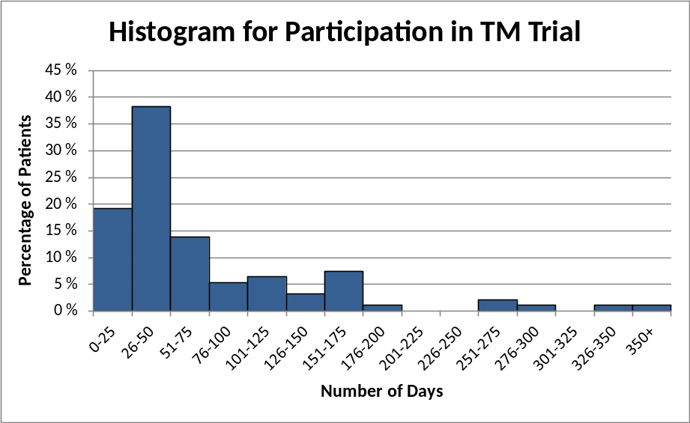
Figure 2: Histogram of Participation Duration [number of days] in TM Trial

In total, we have analysed 4970 datasets for this study received by the telehealth service, each containing a pair of pulse-oximetry measurements (pulse and SpO₂), or a set of answers to the daily questionnaire, or a combination of those. Each dataset originates from one patient, and is tagged with an (anonymized) patient identifier and the date and time when the monitoring data was collected (i.e. when the measurement was done or the daily questionnaire answered) .There could be multiple datasets for one patient for one day, e.g. in case the measurement or the questionnaire had been executed and transmitted multiple times. For the health status level assessment, the first reported data of the day is used, as the result potentially triggers an alert to the telehealth nurses for required follow-up support or treatment.
An overview of the development of the pulse-oximetry data (measurements of pulse and SpO₂) reported by the patients during the first 90 days of their trial involvement is shown in Figure 3.
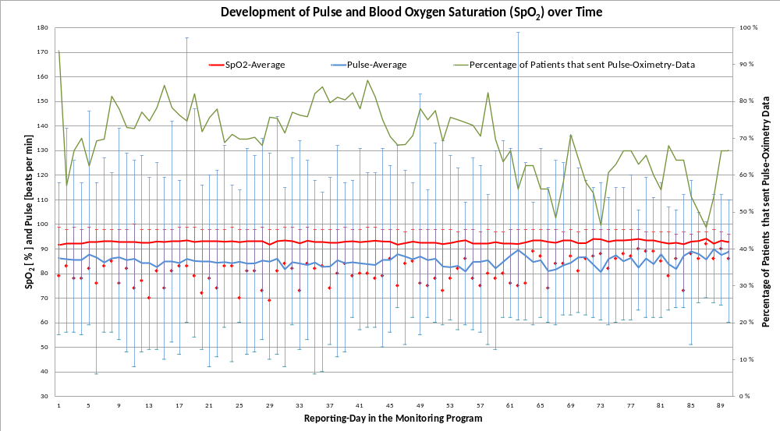
Figure 3: Development of reported Pulse and Blood-Oxygen Saturation (SpO₂)
Between 88 of all 94 equipped patients on day 1 (94%) and 16 of 24 patients still equipped on day 90 (67%) have sent measurement reports (green line, right y-axis). On day 30, 65 patients still had the equipment and 49 sent measurements (75%), and 21 of 33 equipped patients (63%) reported on day 60. For each reporting day the average pulse and SpO₂ values (calculated from all received patient reports) together with their min and max values are plotted (blue and red line respectively, left y-axis and scale for both parameters).
Analogue the development of the self-reported health symptoms, taken from the received daily questionnaire responses of the patients during the first 90 days of their involvement in the monitoring program, is shown in Figure 4.
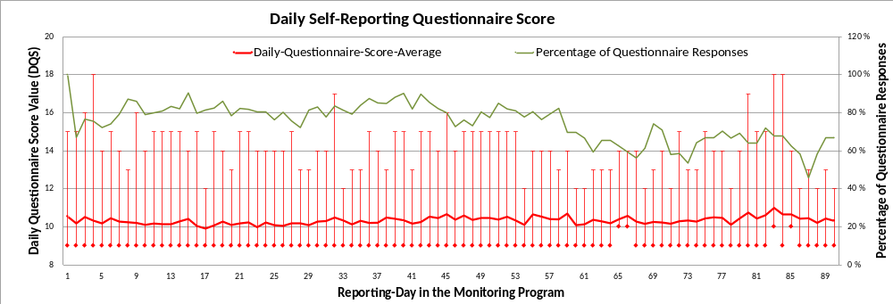
Figure 4: Development of Daily Self-Reporting Questionnaire Score
It contains for each trial-day the average of all received Daily Questionnaire Score values (DQS, see 2.2.3.3), as well as the min (lowest = “best” possible value is 9) and max (highest = “worst” possible value is 19) of all responses from that day. Also the percentage of patients that have sent questionnaire responses on each reporting-day is plotted (green line, right y-axis), in relation to the number of patients who still are equipped with the tablet device. While on the first day, all 94 patients equipped with the tablet device sent a questionnaire response, only 54 of 65 patients (83%) sent a response on day 30, 23 of 33 (70%) on day 60, and 16 of 24 (67%) on day 90, respectively.
The overall average duration of participation in the telemonitoring services was 70 days, with a little difference between the last day of pulse-oximetry reporting (70.1) and the reporting of daily questionnaire answers (70.4). Figure 5 illustrates the percentage of patients (from the 94 patients starting on day 1) participating for at least 7, 14, 30, 60, and 90 days, respectively, in the telemonitoring services.
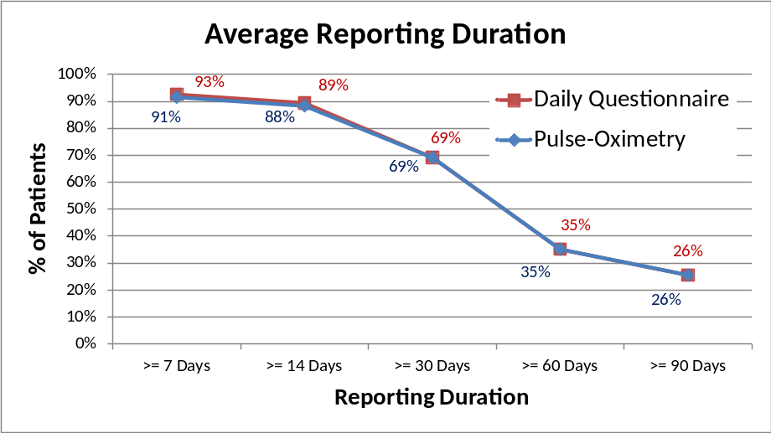
Figure 5: Involvement Duration in TM Services
Another perspective on the utilization of the telemonitoring services is the completeness of the reporting, i.e. the ratio of patients with telemedical equipment that regularly send measurements and questionnaire answers. Figure 6 shows the percentage of patients that report continuously every day for the first 7, 14, 30, 60, and 90 days, respectively, both for the daily questionnaire and the pulse-oximetry data.
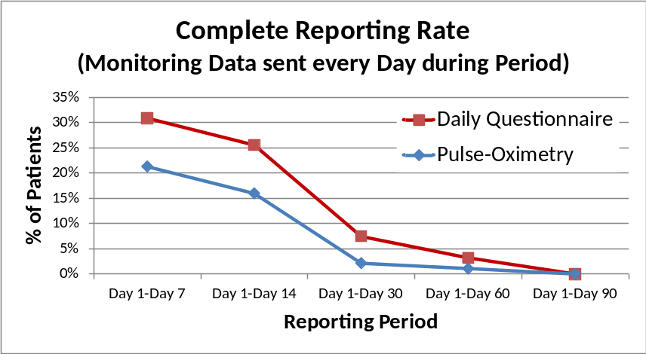
Figure 6: Rate of Complete Reporting
The corresponding average daily reporting rate, i.e. the average percentage of days of the considered periods when monitoring data (pulse-oximetry measurements and daily questionnaire answers) have actually been sent, is illustrated in Figure 7. An average of 75% of days of the period “Day 1 to Day 30” for example means that the patients have sent reports in average on 22.5 days of the 30-days-period, and 67% of the days in period “Day 1 to Day 90” correspond to an average of 60 days reported during the 90 days period.
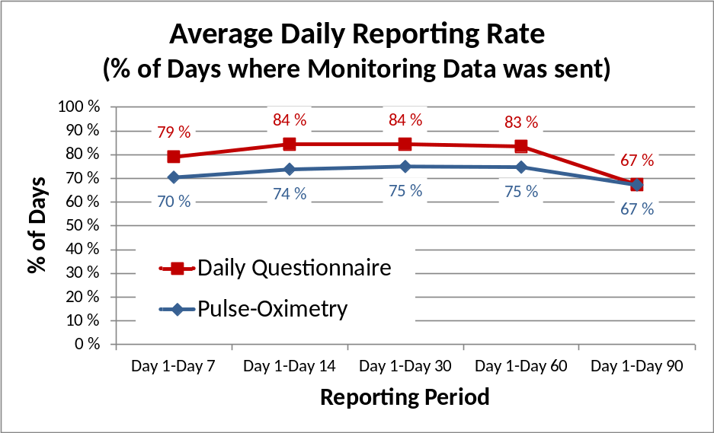
Figure 7: Average Reporting Rate [% of Days reported]
For the analysis of the health status assessment algorithms we have selected a sub-group of 33 patients (i.e. 35% of the total of 94 patients), that have reported pulse-oximetry measurements and/or answers to the daily questionnaire on a minimum of 25 days during the first 30 days, i.e. during the High and the Reduced Level of Telemonitoring Service phases.
First, the health status level categorisation according to ‘green, yellow, and red’ alerts, were assessed before they were analysed and possibly overwritten by the telehealth nurses. Monitoring 33 patients over 30 days corresponds to a total of 990 “patient-reporting-days”, of which we received 928 reported datasets (94%), while on a total of 62 days individual patients didn’t report. In total, 460 patient-reporting-days (46%) were assessed with “green” level (indicating a stable condition of the patient on that day), 275 (28%) with “yellow” (alerting the nurse of a notable condition), and 193 (19%) with “red” level. The frequency of each health status level (averaged over all patients and all days of the considered periods) is illustrated in Figure 8.
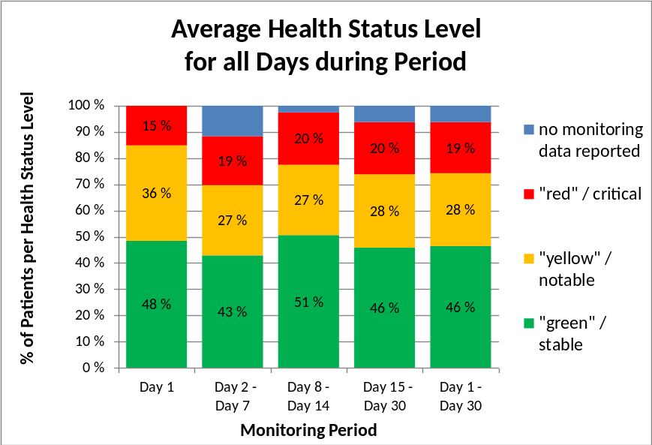
Figure 8: Unadjusted Average Health Status Level during selected Monitoring Periods
The telehealth nurses could then manually overwrite the automatically-calculated health status assessment levels, based on their experience with the health condition of each individual patient, or following a phone or video consultation. This results in the distribution of health status levels as illustrated in Figure 9.
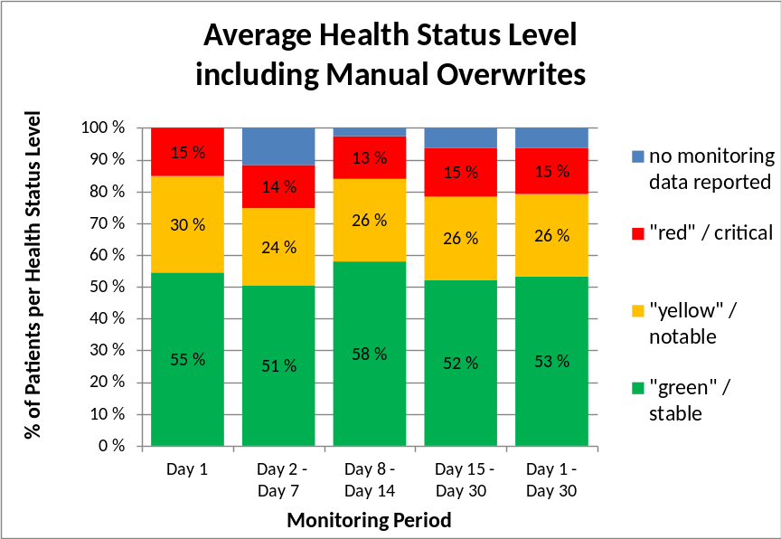
Figure 9: Adjusted Average Health Status Level including Manual Overwrites by Telehealth Nurses
In total 101 assessments, i.e. 10.2% of all 990 “patient-days” were modified manually, 80.8% were unchanged, and 9% were impossible to assess due to lack of reported data. An overview of the type of the adaptation and the reason (looking at initial and adapted health status assessment levels) is given in Table 7.
Table 7: Analysis of Manual Overwrites of Health Status Level Assessment with Algorithm Alternative 1
Type of Adaptation  (related to all Assessments) |  |  | Reasons for Adaptation  (related to Overwrites)
false-high | red to yellow | 2.7 % | Pulse-Assessm. too high |  |  |  | 41.6 %
false-high | yellow to green | 5.3 % | SpO₂-Assessm. too high |  |  |  | 4.0 %
false-high | red to green | 1.7 % | Pulse- and SpO₂-Assessm. too high |  |  |  | 3.0 %
false-high |  |  | Daily Quest.-Assessm. too high |  |  |  | 38.6 %
false-high |  |  | Pulse- and Daily Quest.-Assessm. too high |  |  |  | 7.9 %
false-high | Sum | 9.7 % | Sum |  |  |  | 95.0 %
false-low | green to yellow | 0.4 %
false-low | yellow to red | 0.1 %
false-low | green to red | 0.0 %
false-low | Sum | 0.5 % | All initial Assessm. Levels too low |  |  |  | 5.0 %
Total |  | 10.2 % | Total |  |  |  | 100 %

Resulting from our retrospective analysis of 928 reported datasets, the impacts of new reference- and corresponding cut-off values for the assessment of the pulse-oximetry data according to “cut-off value algorithm 2” (see section 2.2.3.1 above) are shown in Table 8. We have calculated the health status levels based on the new cut-off values, and have compared those (analogue to the process above) with the final assessment of the trial system including the health status levels overwritten by the telehealth nurses. Hence, we analyse the adjustments that would be required to reach the final, adjusted assessment (Figure 9) from the assessment calculated with the alternative algorithm. In total 190 new assessments (corresponding to 19.2% of all 990 considered “patient-days”) would be different from the adjusted assessments, 71.8% would be the same, and 9% of the data were not reported.
Table 8: Impact of Alternative Cut-off Values for Pulse-Oximetry Assessment with Algorithm Alternative 2
Type of required Adaptation  (related to all Assessments) |  |  | Reasons for required Adaptation  (related to Number of Differences)
false-high | red to yellow | 0.9 % | Pulse-Assessm. too high | 10.0 %
false-high | yellow to green | 5.3 % | SpO₂-Assessm. too high | 1.1 %
false-high | red to green | 0.7 % | Daily Quest.-Assessm. too high | 23.2 %
false-high |  |  | Pulse- and Daily Quest. Assessm. too high | 1.6 %
false-high | Sum | 6.9 % | Sum | 35.8 %
false-low | green to yellow | 4.8 %
false-low | yellow to red | 3.8 %
false-low | green to red | 3.6 %
false-low | Sum | 12.3 % | All new Assessm. Levels too low | 64.2 %
Total |  | 19.2 % | Total | 100 %

While the percentage of false-high assessments (6.9%) is lower than the percentage of health status levels reduced manually by the telehealth nurses (9.7%, see Table 7), the ratio of health status levels that are false-low has risen from 0.5% to 12.3%.
The alternative “algorithm 3” for the determination of cut-off values (see 2.2.3.1) only considers the “green” and the “red” health status assessment levels. By far most of the reported data assessed as “yellow” according to the final evaluation by the trial system and the adaptations by the telehealth nurses would be assessed as “green” if algorithm 3 would be used. In total 320 assessments (corresponding to 32.5% of all 990 considered “patient-days”) would be different from the initial assessments by alternative 1, and 58.5% would be unchanged. 30.7% of all assessments would be lower than the otherwise “yellow” or “red” evaluated monitoring data, making this assessment algorithm less sensitive with a higher risk to miss potentially critical conditions of patients, i.e. of “false-low” evaluations. More details of the impacts of the “assessment and cut-off value algorithm 3” are provided in Table 9.
Table 9: Impact of Alternative Assessment Algorithm 3
Type of required Adaptation  (related to all Assessments) |  |  | Reasons for required Adaptation  (related to Number of Differences)
false-high | red to yellow | 1.1 % | Pulse-Assessm. too high | 3.1 %
false-high | yellow to green | 0.0 % | SpO₂-Assessm. too high | 1.2 %
false-high | red to green | 0.7 % | Daily Quest.-Assessm. too high | 1.2 %
false-high | Sum | 1.8 % | Sum | 5.6 %
false-low | green to yellow | 24.4 %
false-low | yellow to red | 0.0 %
false-low | green to red | 6.3 %
false-low | Sum | 30.7 % | All new Assessm. Levels too low | 94.4 %
Total |  | 32.5 % | Total | 100%

Discussion
The examined trial system facilitates the remote monitoring of home-based COPD-patients and the provision of decision support information for the prioritization of follow-up support and treatment by telehealth nurses in a telemedical centre, in cooperation with GPs and medical specialists in hospitals. The development of the self-reporting application for the patients (section 2.2.1) and the telehealth service for the provision of monitoring data and decision support information for the healthcare professionals (section 2.2.3) has followed a User-Centred Design approach[27], aiming at high usability of the user-interaction and user-friendly user interfaces, which has been evaluated in separate studies [15, 24]. The active participation in the trial and utilization of the equipment for continuous and regular, daily reporting of pulse-oximetry measurements and health symptoms by patients is important for the reliable, automatic health assessment by the telehealth system and the implemented rule-based assessment algorithms with its underlying cut-off values. Changes of certain monitoring data from one day to the next are important to identify notable or even critical exacerbations.
The participation duration in the trial, determined by the availability of the monitoring and self-reporting equipment for the patients and the – at least occasional – reporting of data, can be seen in Figure 5: around 90% of the recruited patients send reports at least during the first 14 days (High Level of Telemonitoring Service phase), more than 70% of the patients still participate the trial during the Reduced Level of Telemonitoring Service phase, and approximately 25% have kept the equipment and reported monitoring data for more than 90 days. As long as the patients have the monitoring equipment, they use it on average for at least 2/3rd of the days to send monitoring data (Figure 7). The self-reporting of health symptoms along the daily questionnaire was reported to be less complex than obtaining the pulse-oximetry measurements. But then, just a few patients send complete, daily monitoring data (Figure 6): even during the first 14 days (High Level of Telemonitoring Service phase), just 16% send pulse-oximetry measurements every day, and 25% use the daily questionnaire day-to-day.
There are various reasons for the limited completeness of the reporting of monitoring data: as mentioned, technical problems or difficulties to use the equipment can distract the patients from collecting or sending the data. On the other side, the better a patient subjectively feels, the lower would be the need to report data about the condition. Hence, the lack of monitoring data does not necessarily indicate a bad or even alert condition, but may indicate the opposite, i.e. a stable health status. However, with the algorithms of the telehealth service, this is not possible to interpret, since patient data is necessary for such assessments. As long as the overall health condition of a patient is unknown or unstable, the lack of monitoring data should rather trigger an alert to follow-up with a remote check-up of the patient (e.g. by phone or video call) or with a reminder to send monitoring data. In case a patient condition is known and overall stable – as often the case in long-term monitoring of patients with chronic disease - the lack of data for one or a few days can be treated differently, usually assuming no significant changes of the health condition. This in turn requires a system that can learn behavioural characteristics of a patient, and that can identify a good, healthy, stable condition and distinguish that from a condition in deterioration.
The health status of the monitored patients is – on average – quite constant during the trial period. The measured pulse-oximetry data (Figure 3) does not show significant mean changes during the first 90 days, while extreme values (as extreme high or low pulse or very low SpO₂ measurements) become less frequent with increasing monitoring duration, i.e. beyond day 60. Certainly, the reduced number of participating patients causes a selection bias here that not can be corrected. Such bias is also influenced by the likely drop in daily registration among those with an improved condition. Further, the average score value from the daily self-reporting questionnaire of health symptoms (Figure 4) shows a quite low average figure during the whole first 90 monitoring days, reflecting a stable and confident subjective health status. Beyond day 70 the number of higher maximum values of the score increases though, indicating a “worse” or even “much worse” subjective health perception of some patients, most likely also influenced by a selection bias of those with a more chronically unstable condition.
The automatically calculated health status level (Figure 8) confirms this observation: the percentage of the selected 33 patients that are assessed as “stable”, “notable” and “critical”, averaged over all days of different considered monitoring periods within the first 30 days of the trial participation, is more or less constant, with nearly 50% of the assessments being “green”, around 30% being “yellow”, and just around 20% being “red”.
Algorithm 1 (refer to section 2.2.3.1) provides adaptation of cut-off values to the patients’ condition through individual reference values and includes a “yellow” warning level for increased sensitivity of the assessment. The manual overwriting of the automatic health status level assessment by the telehealth nurses resulted in the new health status level distribution illustrated in Figure 9. The analysis of the modifications (Table 7) shows, that about 10% of the assessment levels were set lower by the nurses, mainly from “yellow” to “green”, and that in most cases either the assessments of the measured pulse values were too high, or the single items of the daily questionnaire. That means, that in relation to the modified assessment of the health status by the nurses, the automatic assessment by the telehealth service might be too sensitive, causing a number of unnecessary warnings or alerts.
Alternative algorithm 2 for the determination of cut-off values (see section 2.2.3.1) is an attempt to adapt the cut-off values more to the individual and slowly changing health status of each individual patient, while still identifying critical conditions. We have assessed the monitoring data from the same 33 selected patients again retrospectively, and compared the results with the assessment following algorithm 1 including overwrites by the telehealth nurses. As seen in Table 8, the number of “false-high” assessments is reduced compared to the modifications made manually in the previous algorithm (down to < 7%), in particular the previously too sensitive assessment of pulse values is down to 10%. On the other side, the reduced sensitivity, following the dynamically-adapting cut-off values, lead to an increased number of assessments with a lower health status as previously (12%), which could include false-low assessments. The retrospective calculation of health status levels does not consider though whether the lower-than-before assessed monitoring data reflect a critical condition, which would have been adapted by the nurses correspondingly.
The alternative algorithm 3 considers only the “green” and the “red” assessment levels, and a static, generic cut-off value for pulse measurements, similar as used in Emergency Triage. This assessment of the monitoring data with “alternative 3” cut-offs leads to redefined alerts in more than 32% of all cases, mostly due to false-low redefinitions. In relation to the adjusted assessment (Figure 9), 242 of the previous 257 yellow assessments (24.4% of all assessments) and 62 of the previous 144 “red” assessments (6.3% of all) were redefined as “green” (Table 9). This indicates that static and generic, non-personalized cut-off values may come along with reduced sensitivity and a higher risk of false-low assessments.
There is one major objection to our above statements: The final, readjusted, colour-based alert decision by the telehealth nurse is considered the gold standard for our conclusions and hence as a qualitatively correct medical decision. That might not be the case. The challenge for future research is to define a more reliable, medical parameter as the gold standard for such research.

Conclusions / Outlook / “Lessons Learned”
The automatic, computer-based assessment of monitoring data from home-living patients with chronic diseases, as explored in this trial system, utilizes algorithms and rules that depend on cut-off values for certain measures or self-reported parameters, thereby reflecting the health condition of the patients. As such algorithms and rules look at the day-to-day development and changes of the reported data in order to identify notable or critical abnormalities, the accuracy and reliability of the health status assessments depend highly on continuous reporting of the required parameters by the patients, at least on a daily or more frequent, regular basis. As this trial has revealed, there are different reasons causing short or longer interruptions of the self-reporting of monitoring data. On the one hand, technical problems or usability challenges with the provided monitoring and reporting equipment can prevent the patients from sending the monitoring data. On the other hand, a stable and improving subjective health and well-being status can also make patients forget the importance or relevance of reporting health data.
Another critical aspect for the accuracy of the health status assessments is the determination of cut-off values that define certain health status levels, and that thus are crucial for the rule-based assessment. The results from the trial system have shown, that static, generic cut-off values, as used for example for emergency medicine triage, are sufficient to trigger emergency alerts, while they do not support decisions by telehealth nurses (and also for GPs and medical specialists) with high accuracy and reliability. Instead, cut-off values have to be personalized according to the individual health condition and common levels of health parameters. Predetermined, personally adapted cut-off values defined at the beginning of a telehealth monitoring period of a patient, might not adapt sufficiently with the dynamic general health condition of a patient. With “alternative algorithm 2” a more dynamically adaptive determination of cut-off values has been evaluated, which should be tested in future prospective trials focusing on accuracy and reliability of the health status assessment and on a proper definition of a gold standard to test sensitivity and specificity against. The results from the so far tested algorithms are not satisfactory enough to provide for reliable (avoiding false-negative) and also efficient (avoiding false-positive) alerts.
Health status assessment and decision support systems which are based on more or less static rules, algorithms and cut-off values have significant limitations, especially regarding the analysis of data from patients with multiple morbidities. Long-term monitoring of patients with multiple morbidities requires analysis of more health parameters, which can vary from patient to patient and have complex interaction and dependencies between each other. Therefore, more personalized, adaptive and intelligent assessments are needed. An approach of ongoing research work is the utilization of smart, self-learning systems with artificial intelligence (AI) technologies. Machine learning technologies allow to automatically retrieve knowledge from reported and even not-reported data, leading to risk estimations and determination of health trends based on statistical probabilities. The development of appropriate machine learning algorithms and corresponding real-time data evaluation systems requires more clinical data. The tested telehealth trial system has shown strengths and advantages in the patient interaction, data collection, timely, reliable and safe transmission of monitoring data, and the interaction with health professionals. Ongoing research work will combine, test and evaluate this in combination with smarter, AI-based assessment and decision support algorithms.
While the focus of this study has been on medical informatics perspective of the calculation of decision support information, advantages for remotely monitored patients (for example reduced stress level and improved well-being while living at home [26], increased mastery and control in managing their disease [27]) and for the telehealth service providers (for example reduced on-site visits by home nurses and less hospital readmissions) can be expected, and are subject of further ongoing studies about the medical and operational efficiency. As soon as more reliable analysis and risk detection algorithms are in place, specialized nurses at telehealth services can be relieved from the continuous long-term remote patient monitoring, which can be provided by automatic feedback and advice systems instead.

Authors' contributions
Martin Gerdes: technical lead of pilot system development for acquisition of data; conception of study and drafting of article, with focus on “Materials and Methods”, presentation of data, discussion of results, and conclusions; finalization and submission of article
Frode Gallefoss: medical lead of pilot study design; supervision of trial execution; analysis and interpretation of data; revising and approval of article with focus on medical background, presentation of results, discussion and conclusion
Rune W. Fensli: technical and scientific lead of pilot system development; drafting and revising of article with focus on scientific background, analysis and interpretation of results, and conclusions; approval of article

Acknowledgements
We thank all test participants for their contributions in the trial project.
Furthermore, we thank all partners of the South-Norwegian United4Health project for their support and collaboration. Especially, we would like to thank Inger Alice Naley Ås at Sørlandet Hospital and Karoline Vassbø Nyhus at Municipality of Kristiansand for their valuable help in collecting patient data.
This work was supported by UNIversal solutions in Telemedicine Deployment for European HEALTH care, 2013-2015 ICT PSP [call identifier CIP-ICT PSP-2012-3] and Point-of-Care Services Agder, sub-project financed by the Research Council of Norway, 2013-15, [ref 227131/O70].

Statement on conflicts of interest
The authors have been involved in the co-design processes for developing the telemedicine solution used in the South-Norway trial of the United4Health project.
There are no other conflicts of interests.

Summary table
Existing knowledge on remote monitoring and health status assessment:
- Methods from Emergency Department triage assessment have been adopted in some telemedicine systems, where patient-measurements are used for medical decision support and alert notifications, but the specificity and reliability is not known.
- However, long time-series of patient-measurements of vital signs parameters is different from a snap-shot measurement in an emergency situation, and actual algorithms have in some papers been evaluated according to retrospective analysis.
- It is supposed that patients can use new telemedicine systems, as long as the systems are designed in a user-friendly way, and technical skills and health literacy are no prerequisite for the patients’ vital signs measurements on daily bases at home for long-term.
What this study added to our knowledge:
- In this paper, we have presented our experience from a clinical trial with COPD patients reporting daily measurements of SpO₂ and pulse together with a symptom specific questionnaire, indicating that patients for several reasons will not conduct health status reports to the telehealth system each and every day.
- In a detailed evaluation of a sub-group of 33 patients reporting 924 datasets, the telehealth nurse has overwritten the automatically calculated health status score in 10.2% of the cases, with 9.7% turning out as false high, indicating that the algorithm used in the clinical trial has weaknesses that should be improved.
- Actual algorithms to calculate a health status score need to be adaptive to individual tailored long-time changes; however, there is a lack of golden standards to compare actual methods and algorithms for their specificity and reliability.
- Future research should try to evaluate smart self-learning systems with artificial intelligence, and define methods for evaluation of the reliability and specificity against a golden standard for health status level assessment.

References
[1] United4Health, FP7 EU project United4Health, Umbrella project: http://www.united4health.eu/; Norwegian project: http://www.united4health.no/, 2013.
[2] A. Steventon, M. Bardsley, J. Billings, J. Dixon, H. Doll, S. Hirani, M. Cartwright, L. Rixon, M. Knapp, C. Henderson, A. Rogers, R. Fitzpatrick, J. Hendy, S. Newman, Effect of telehealth on use of secondary care and mortality: findings from the Whole System Demonstrator cluster randomised trial, BMJ, 344 (2012).
[3] B. Odeh, R. Kayyali, S. Nabhani-Gebara, N. Philip, P. Robinson, C.R. Wallace, Evaluation of a Telehealth Service for COPD and HF patients: Clinical outcome and patients’ perceptions, J Telemed Telecare, 21 (2015) 292-297.
[4] A. Farmer, C. Toms, M. Hardinge, V. Williams, H. Rutter, L. Tarassenko, Self-management support using an Internet-linked tablet computer (the EDGE platform)-based intervention in chronic obstructive pulmonary disease: protocol for the EDGE-COPD randomised controlled trial, BMJ Open, 4 (2014).
[5] C. Velardo, S.A. Shah, O. Gibson, H. Rutter, A. Farmer, L. Tarassenko, Automatic generation of personalised alert thresholds for patients with COPD, 2014 22nd European Signal Processing Conference (EUSIPCO), 2014, pp. 1990-1994.
[6] S.A. Shah, C. Velardo, O.J. Gibson, H. Rutter, A. Farmer, L. Tarassenko, Personalized alerts for patients with COPD using pulse oximetry and symptom scores, 2014 36th Annual International Conference of the IEEE Engineering in Medicine and Biology Society, 2014, pp. 3164-3167.
[7] G. Segrelles Calvo, C. Gómez-Suárez, J.B. Soriano, E. Zamora, A. Gónzalez-Gamarra, M. González-Béjar, A. Jordán, E. Tadeo, A. Sebastián, G. Fernández, J. Ancochea, A home telehealth program for patients with severe COPD: The PROMETE study, Respiratory Medicine, 108 (2014) 453-462.
[8] S.L. Dong, M.J. Bullard, D.P. Meurer, I. Colman, S. Blitz, B.R. Holroyd, B.H. Rowe, Emergency Triage: Comparing a Novel Computer Triage Program with Standard Triage, Academic Emergency Medicine, 12 (2005) 502-507.
[9] H.M. Lossius, M. Rehn, K.E. Tjosevik, T. Eken, Calculating trauma triage precision: effects of different definitions of major trauma, Journal of Trauma Management & Outcomes, 6 (2012) 1-7.
[10] C.D. Mathers, D. Loncar, Updated projections of global mortality and burden of disease, 2002-2030: data sources, methods and results, Geneva: World Health Organization, (2005).
[11] J.A. Wedzicha, J. Vestbo, Can patients with COPD self-manage?, The Lancet, 380 (2012) 624-625.
[12] N. Archer, K. Keshavjee, C. Demers, R. Lee, Online self-management interventions for chronically ill patients: Cognitive impairment and technology issues, Int J Med Inform, 83 (2014) 264-272.
[13] P.H. Lilholt, L.K.E. Hæsum, L.H. Ehlers, O.K. Hejlesen, Specific technological communication skills and functional health literacy have no influence on self-reported benefits from enrollment in the TeleCare North trial, Int J Med Inform, 91 (2016) 60-66.
[14] J. Hofstede, J. de Bie, B. van Wijngaarden, M. Heijmans, Knowledge, use and attitude toward eHealth among patients with chronic lung diseases, Int J Med Inform, 83 (2014) 967-974.
[15] B. Smaradottir, S. Martinez, M. Gerdes, R. Fensli, User-Centered Design of a COPD Remote Monitoring Application; Experiences from the EU-project United4Health, International Journal on Advances in Software, 8 (2015) 350-360.
[16] L. Liu, E. Stroulia, I. Nikolaidis, A. Miguel-Cruz, A. Rios Rincon, Smart homes and home health monitoring technologies for older adults: A systematic review, Int J Med Inform, 91 (2016) 44-59.
[17] O. Adeogun, A. Tiwari, J.R. Alcock, Models of information exchange for UK telehealth systems, Int J Med Inform, 80 (2011) 359-370.
[18] H.R. Champion, W.J. Sacco, D.S. Hannan, R.L. Lepper, E.S. Atzinger, W.S. Copes, L.R. H. Prall, Assessment of injury severity: the Triage Index, Critical Care Medicine, 8 (1980) 201-208.
[19] R. Shelton, The Emergency Severity Index 5-level triage system, Dimensions of critical care nursing : DCCN, 28 (2009) 9-12.
[20] O. Banerjee, M. Tanner, Telehealth research, International Journal of Integrated Care, 12 (2012) e44.
[21] K. Nordenholz, J. Ryan, B. Atwood, K. Heard, Pulmonary Embolism Risk Stratification: Pulse Oximetry and Pulmonary Embolism Severity Index, Journal of Emergency Medicine, 40 (2011) 95-102.
[22] A.R. Hardisty, S.C. Peirce, A. Preece, C.E. Bolton, E.C. Conley, W.A. Gray, O.F. Rana, Z. Yousef, G. Elwyn, Bridging two translation gaps: A new informatics research agenda for telemonitoring of chronic disease, Int J Med Inform, 80 (2011) 734-744.
[23] B. Dinesen, B. Nonnecke, D. Lindeman, E. Toft, K. Kidholm, K. Jethwani, H.M. Young, H. Spindler, C.U. Oestergaard, J.A. Southard, M. Gutierrez, N. Anderson, N.M. Albert, J.J. Han, T. Nesbitt, Personalized Telehealth in the Future: A Global Research Agenda, J Med Internet Res, 18 (2016) e53.
[24] B. Smaradottir, M. Gerdes, S. Martinez, R. Fensli, The EU-project United4Health: User-centred design of an information system for a Norwegian telemedicine service, J Telemed Telecare, (2015).
[25] M. Gerdes, B. Smaradottir, R. Fensli, End-to-End Infrastructure for Usability Evaluation of eHealth Applications and Services, Scandinavian Conference on Health Informatics, Linköping University Electronic Press, Grimstad, Norway, 2014, pp. 53-59.
[26] T.K. Vatnøy, E. Thygesen, B. Dale, Telemedicine to support coping resources in home-living patients diagnosed with chronic obstructive pulmonary disease: Patients’ experiences, J Telemed Telecare, (2016).
[27] T.L. BARKEN, E. THYGESEN, U. SÖDERHAMN, Living with Chronic Obstructive Pulmonary Disease and Being Followed Up Through Telemedicine–A Phenomenological Approach, Nursing Informatics 2016, (2016) 926.
[28] Y.B.D. Trinugroho, Information Integration Platform for Patient-Centric Healthcare Services: Design, Prototype and Dependability Aspects, Future Internet, 6 (2014) 126-154.
[29] D.f. e-helse, Code of Conduct, Direktoratet for e-helse, ehelse.no, 2015.
[30] ehelse.no, Code of conduct for information security (The healthcare and care services sector), 5 June 2014, Helsedirektoratet Norge, ehelse.no.
[31] M. Gerdes, R. Fensli, End-to-end Security and Privacy Protection for Co-operative Access to Health and Care Data in a Telehealth Trial System for Remote Supervision of COPD-Patients, 13th Scandinavian Conference on Health InformaticsTromsø, Norway, 2015.

“Degree COPD” is defined according to the COPD stages 1(mild), 2 (moderate), 3 (severe) and 4 (very severe)
This date and time of monitoring can be different from the date/time of transmission from the patient tablet PC device or the reception of the data at the telehealth service in the HIS infrastructure. In case of connectivity problems of the patient tablet PC device, the data is stored and transmitter as soon as connectivity is established again. For the health status assessment, the date/time of monitoring is crucial (not the date/time of reception by the telehealth service).

